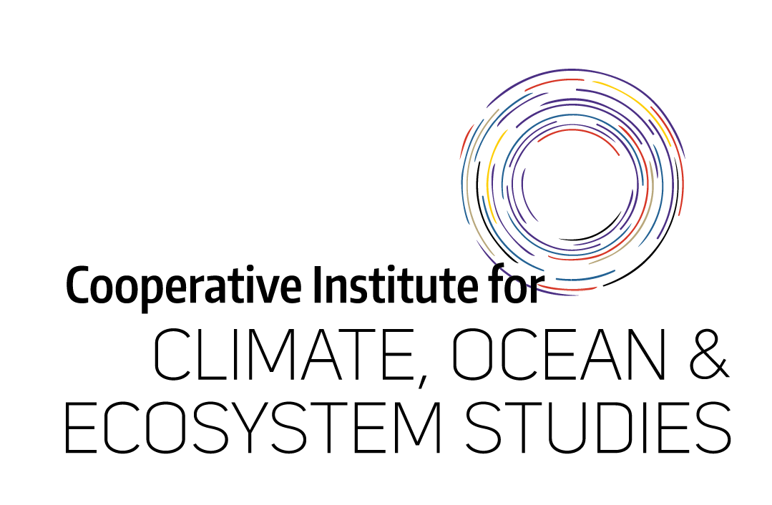

**Diversity, Equity, and Inclusion Funding Application**

|  |  |
| --- | --- |
| Employee Name  Click or tap here to enter text. | Job Title  Click or tap here to enter text. |
| Briefly describe your role at CICOES:  Click or tap here to enter text. | |

|  |  |  |
| --- | --- | --- |
| What type of DEI activity would you like to use funding for?  Attend an off-site workshop Bring in a facilitator for an on-site workshop DEI Speaker  POD course Other | | |
| Please describe the DEI activity. If it is a group workshop, include the topic and the number of people who will attend; if this is for an off-site workshop, include the date, location, and title:  Click or tap here to enter text. | | |
| How will this activity increase education or engagement around DEI topics at CICOES? How do you propose to evaluate the impact of this activity?  Click or tap here to enter text. | | |
| If this is an off-site workshop or POD course, please describe in detail how you plan to share learnings with others at CICOES (ex: give an overview at your next team meeting, host a brown-bag discussion):  Click or tap here to enter text. | | |
| What is the total estimated cost?  Click or tap here to enter text. | What amount are you requesting from CICOES?  Click or tap here to enter text. | How did you hear about this DEI activity?  Click or tap here to enter text. |

|  |  |  |
| --- | --- | --- |
| CICOES Supervisor Signature: | CICOES Supervisor Name:  Click or tap here to enter text. | Date:  Click or tap to enter a date. |
| NOAA Sponsor Signature:* | NOAA Sponsor Name:  Click or tap here to enter text. | Date:  Click or tap to enter a date. |

Please send completed form to Abby Zorn at [azorn@uw.edu](mailto:azorn@uw.edu)

*Required unless you do not work on NOAA WRC Campus