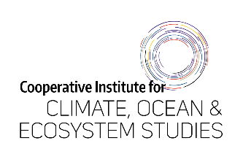

Employee Self Evaluation Form

May 1, 2025 – April 30, 2026

(to be completed by employee)

Employee: ____________________________________

- List the job-related, outreach and professional development goals you set last year. Include any modifications from the mid-year check-in.

- Goal progress and other accomplishments: Describe what went well while working on these goals and any other accomplishments.

- Goal challenges: Describe challenges you faced while working on your goals or otherwise. Comment on anything that could have been done differently or better and if there is anything in particular you would like feedback on.

- Job-related goals: List 3-5 job-related goals for the upcoming year. Make goals as S.M.A.R.T (Specific, Measurable, Achievable, Relevant, Time-bound) as possible. You will finalize these goals with your supervisor.

- Professional development goals: List professional development goals for the upcoming year. What skills would you like to improve or acquire and how will you do this? You will finalize these goals with your supervisor.

- Outreach/Service goals: List outreach goals for the upcoming year, e.g. presenting at K-12 STEM days or in classrooms, participating in special events like NOAA Science Camp, or tabling at career fairs, mentoring interns etc. Are there any particular communities or organizations you’d like to work with?

- What feedback (if any) do you have for your supervisor, NOAA sponsor, or the CICOES administration? Is there something any of them could have done differently to help you overcome a challenge? You may also send any of this feedback directly to the HR manager.

Signed: ______________________________________________________________
UW Employee Date

Signed: ______________________________________________________________
UW Supervisor Date

