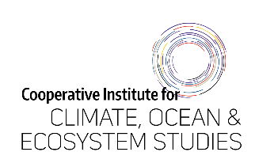

Performance Evaluation Form

May 1, 2025 – April 30, 2026

(to be completed by supervisor)

Employee: ____________________________________

- Goal progress and other accomplishments: Review the job-related, outreach, and professional development goals set at the beginning of the year. Provide feedback on what your supervisee did well while working on these goals and any other accomplishments.

- Goal challenges and areas of improvement: Review the job-related, outreach, and professional development goals set at the beginning of the year. Provide feedback on what could have gone better while working on these goals and identify any areas of improvement. Respond to any specific requests for feedback.

- Job-related goals for the upcoming year: After reviewing goals from the self-evaluation finalize a list of job-related goals. Make goals as S.M.A.R.T (Specific, Measurable, Achievable, Relevant, Time-bound) as possible.

- Professional development goals: List professional development goals and a plan to achieve them after discussion with your supervisee.

- Outreach/Service goals: List Outreach/Service goals and a plan to achieve them after discussion with your supervisee.

- Response to employee feedback (if any):

- Indicate here if a mid-year check-in was completed: ______

Signed: ______________________________________________________________
UW Employee Date

Signed: ______________________________________________________________
UW Supervisor Date

